بسم الله الرحمن الرحيم
ولاية الخرطوم/ وزارة التربية والتعليم
مدارس الغيث الأساسية الخاصة
إمتحانات الفترة الأولي للعام الدراسي 2011م – 2012م
الإسم: ......................................................................امتحان:English languageالصف: السادس

question one:Give the opposite:
لا تكتب علي الأشكال التي بجانب الورقة
up | black | big | begin | first
Questions two: Find the odd word:
1/ teacher – class – pupil – bed
2/ orange – cheese – apple – mango
3/ blue – black – board – brown
4/ tiger – cat – dog – goat
5/ English – Arabic – Geography – color
Question three: Find the missing letters:
1/ fam……ly 6/ bo…….k
2/ kitch……n 7/ l……ve
3/ do……..r 8/ aj……g
4/ b……….s 9/ ac……p
Don’t write in the shapes on paper side
5/ h………me 10/ unc……..e
Question four:Match (A) with (B):
(A) brush – red – lion – tall - school
(B) |  | (A)
Short |  |  | 1
Zoo |  |  | 2
Teacher  turn the page ☞ |  |  | 3
Teeth  Don’t write in the shapes on paper side |  |  | 4
Color |  |  | 5
Question five:put these words in their correct order:
Watching – oranges – London – uncle – do
1/ I like ……………………………………………………………. .
2/ Peter lives in ………………………………………………. .
3/ Kamal is ……………………………………………………… .
4/ Everyday I ……………………………. My homework.
5/ My father's brother is my ……………………………. .
Question six: underline the correct word:
home – hoome | 6 | eight - aight | 1
black – blacke | 7 | board – boord | 2
narse – nurse | 8 | abowl – abwl | 3
elefant - elephant | 9 | Picture – bicuter | 4
goot – goat | 10 | have - hav | 5
Question seven: Reorder these sentences:
1/ I boy am a.
………………………………………………………………………………………………………………..
2/ this tree is a.
………………………………………………………………………………………………………………..
لا تكتب علي الأشكال التي بجانب الورقة
3/ Ali playing is.
………………………………………………………………………………………………………………
4/ Nawal in gets up morning the.
………………………………………………………………………………………………………………..
5/ My kamal is name.
………………………………………………………………………………………………………………..
turn the page ☞
Question eight:Name these shapes:
Don’t write in the shapes on paper side

1/ 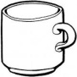 2/ 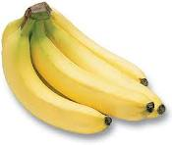 3/ 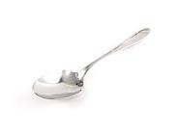 4/ 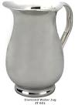 5/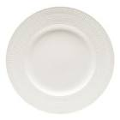

Question nine: Reorder these words:
1/ 2/ 3/ 4/ 5/
bga
droo
hvea
bkoo
rac

…………………………………………………………………………………………………………………….……………………….
Question ten: Draw these times:
1/ five o'clock 2/ seven o'clock 3/ 12 o'clock

4/ six o'clock 5/ o'clock
لا تكتب علي الأشكال التي بجانب الورقة

