بسم الله الرحمن الرحيم

40
مدرسة البصيرة القرآنية الخاصة بنتن – بنات
الإمتحانات الشهرية – أغسطس 2012م
الإسم: .............................................. الصف: السادس المادة: اللغة الإنجليزية

Question one: complete:
(man – women – girl – boy)
1/ Haj Musa is the name of …………………………..
2/ Haja Fatima is the name of ………………………

4
3/ Kamal is name of ……………………………………..
4/ Nawal is name of ……………………………………..
Question two: put the correct word in its Wright place:
(are – is – am)
1/ they …………………………… playing football.
2/ I …………………………………. Reading now.
3/ Lado ………………………….. writing.

10
4/ The girl ……………………….. camping her hair.
5/ the man ……………………… sleeping deeply.
Question three: Write the missing letter:
1/ a penc__l 2/ hous__ 3/ hom__

6
4/ kittch__n 5/ roo__ 6/ hal__

Question four: A/ make words from these letters:
Example:
1/ head 2/ ………………………………………
3/ ……………………………………. 4/ ………………………………………
B/ write the time:
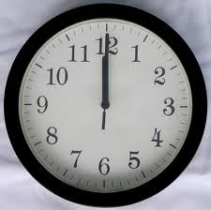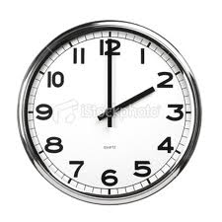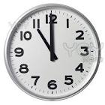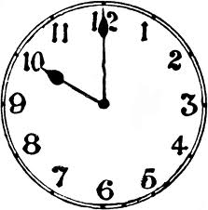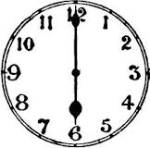

10
Question four: put these words in the correct space:
Bed room – kitchen – port Sudan – bath rooms – sitting room

10
Iam Karrar, I live in a house in ……………………………….. the house has a …………………….. and two ………………………………. It has a ……………………, it has three …………………………..

