بســم الله الرحمـن الرحـيم

إدارة تعليـم الأسـاس ( قـطاع البـاوقـة )
مـدرســــة التكــاوين الأسـاسـية بنــات

ألاســــم : ................................................................................................... الامتـحان التجــريبي رقــــم (2)
English Language 6th class Time: an hour

Q (1): Underline the correct answer: a. , b. or c. (5 m)

- What ____________________ he doing now? a. is b. are c. am
- When does Lado _____________ to school? a. went b. go c. goes
- Fatima likes ____________________ dates. a. eats b. ate c. eating
- He ______________________ like oranges. a. doesn’t b. don’t c. aren’t
- The women _______________________ tea. a. drinking b. drink c. drinks

Q (2): Mark ( √ ) for true and ( × ) for false: (5 m)
- This is a ball. 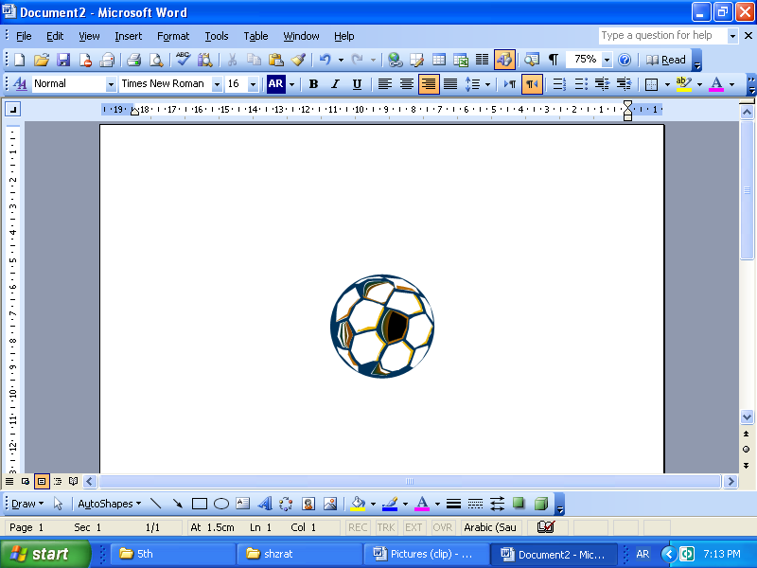 (______________)
- Bananas are red. (______________)
- The stars are far. (______________)
- 25 + 15 = 40 (______________)
- You have two heads. (______________)

Q (3): Find the missing letter: (2 ½ m)

1. pi__ture 2. cupb__ard 3. cl__ssroom 4. br__akfast 5. ra__io

Q (4): Complete the question to match the answers: (5 m)

Has – Where – What – Who - Are

- __________________________ is Malakal? It’s in the south.
- __________________________ wants an orange? Tahir does.
- __________________________ he got a book? Yes, he has.
- __________________________ you a pupil? Yes, I am.
- __________________________ is Zeinab? She is a nurse.

Q (5): Underline the odd word: (2 ½ m)

- pencil blue green white
- bedroom school sitting room kitchen
- pen pencil book spoon
- nose eye leg ear
- two five six four
Q (6): Fill in each space with the given word from the list: (2 ½ m)

@ father - 40 - am - short - Sudanese @

I ___________________ Kamal. I am __________________________ . My _________________________ is a doctor. He is ___________________ years old. He is ____________________________ and fat.

Q (7): Match (A) with (B): (5 m)

A | B | answers
- brush | - animal | - _______________________
- school | - east | - _______________________
- milk | - teeth | - _______________________
- cat | - drink | - _______________________
- direction | - timetable | - _______________________

Q (8): Put a line under the right word between the brackets: (5 m)

- Sudan is my ( school - country - farm ).
- Half is ( on - with - in ) the north.
- ( Is - Can - Are ) you drive a car? Yes, I can.
- April comes ( before - between - after ) May.
- My father’s sister is my ( mother - aunt - uncle )

Q (9): Put the sentences in the correct order in the boxes below: (5 m)

- She has breakfast at ten.
- Amna goes to bed at ten in the evening.
- She gets up at six o’clock in the morning.
- Amna does her homework at eight in the evening.
- Amna is a pupil. She lives in Bawga.
- She goes to school at seven.

1 | 2 | 3 | 4 | 5 | 6
e | …………………... | …………………... | …………………... | …………………... | …………………...

Q (10): Put the opposites of these adjectives: (2 ½ m)

( high - short - thin - unhappy - small)

- tall ___________________________________
- big ___________________________________
- fat ___________________________________
- low ___________________________________
- happy ___________________________________

Good Luck

Mohamad Abakar

