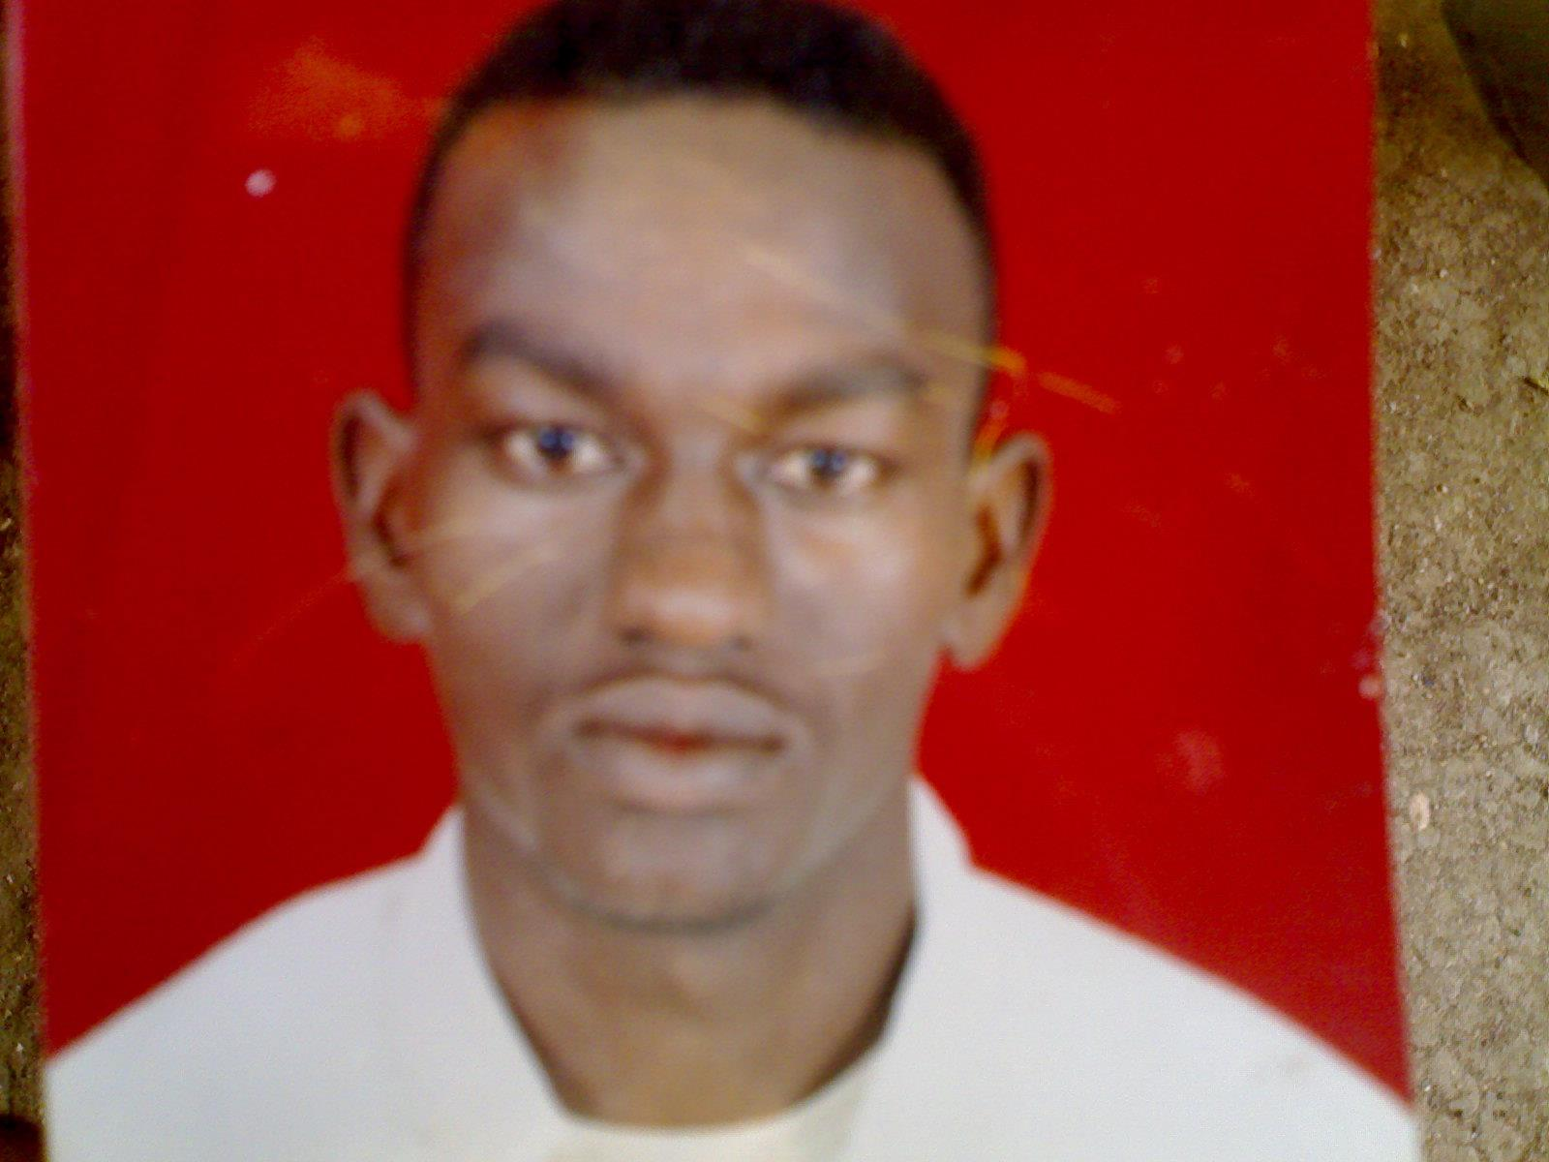

(2) Treasure Island:
Answer the following questions briefly.
1- What’s the name of the writer of (Treasure Island)
= Robert Louis Stevenson.
2- What’s the name of the story writer?
= Robert Louis Stevenson
3- What’s the name of the author of (Treasure Island)?
= Robert Louis Stevenson
4- when and where did Robert born?
= He born in Edinburgh, Scotland in November in 1850.
5- when and where did Robert die?
= He died in Samoa in December in 1894.
6-How long did Robert live?.....
= 44 years.
7- When did the story of Treasure Island start?............ In 1756
8- when did the story of Treasure Island take place?
= In the middle of eighteen century.
9- What’s the name of the story teller? …
= Jim Hawkins.
10- What’s the story (Treasure Island) about? ….
= About pirates who steal Treasure from the ships.
11- What was the name of the inn?
= Admiral Benbow
12- Where it was the inn Admiral Benbow?
= on the south coast of England
13- What did the Captain does when he drunk?
= he sings songs and shout.
14- What is the name of the Inn where the Captain stays?
= the Admiral Benbow Inn.
15- Why Jim likes Long John Silver?
= because he has clever face, tales jokes and laugh a lot.
16- Describe the pirates?
……………………………………………………………………………………………………………………………………………………………………………………………………………………………………………………………………………………………………………………….
17- How old was Jim when the story started?
= He was twelve years old.
18- Where did Jim Hawkins and his parents live?
= They lived in small inn.
19- Who was stayed in the inn for several weeks?
=the old pirates.
20- How did the traveler come?
= by cart pulled by horse.
21- How long did the old Captain or the old pirates stay at the Inn?
= for several weeks.
22- What did the traveler bring with him?
= wooden sea-chest.
23- What kinds of stories did the old Captain tell Jim?
= about pirates and ships, robbing ships and killing men.
24- What did the Captain tell Jim to do for him?
= To watch a man with one leg.
25- Who came to look for the Captain?
the Black Dog
26- Who was Captain Flint?
= he was terrible pirates robbed ships for twenty years an died in south America.
= Blind Pew
27- How was the beggar dressed?
= He was dressed in ragged clothes and wore a green cloth over his eyes.
28- What did Blind Pew give the captain?
= Black Spot.
28- Where did Jim find the key?
= in chain around the dead man’s neck.
29- What did Jim and his mother find in the captain’s sea-chest?
= bag of money and a leather packet.
30- who were the horsemen?
= They were Costumes.
31- who did bring the Costumes to the Inn?
= Dr. Livesey.
32- why Jim and his mother run to the village?
= for help.
= he lives in a big white house on the hill outside the village.
33- where did Captain Flint die?
= He died in south America.
34- Who opened the Leather Packet?
= Dr. Livsey
35- What did they find in the Leather Packet?
= a map
36- What the map shows?
= shows where Captain Flint buried his Treasure.
37- What was written in cross down over the map?
= was written Flint’s map.
38- Why did Trelawney travel to Bristol?
=To charter a ship.
39- Describe Long John Silver?
= his left leg was missed, he can move and run quickly, has clever face, tales jokes and love a lot.
40- How did Jim and Dr. Livesey arrive at Bristol?
= by coach pulled by horses.
41- What’s the name of the ship?
=Hispaniola
42- What’s the name of the ship’s cook?
= Long John Silver.
43- Who was the captain of the ship? ……. =Smollett
44- Where did they cook their food?
= in the galley.
45- what is the galley? The kitchen of the ship.
46- what was Jim’s …………Cabin boy.
47- who was the cook of the ship?……
=Long John Silver.
48- Where did Jim sleep? … in the hammock
49- What did Captain Smollett write, in the ship’s log?
= everything happens on the ship.
50- How long did they sailed?......
=for a month.
51- what is the name of the who marooned on the Island?
= Ben Gunn.
52- Why the men didn’t complain about food?
= because they were afraid from Long John Silver.
53- Who was with Silver, when his leg was shot?
= Blind Pew.
54- What did Silver intend to do when he was talking to the young sailor?
= He wanted to take over the ship.
55- What did Jim do, when the Hispaniola arrived, in the island?
= he run into the jungle
56- How did Jim know about spy-glass hill and the stockade, before he went to the island?
= From the map.
57- Describe the Treasure Island, (the setting). …………………………………………….………………………………………………………………………………………………………………………………………………………………………………………………………………………………………………………………………………………………………………………
58- What did Jim see Long John Silver do, in the Island?
= he was a murder Tom and Alan were killed by Long John Silver.
59- Jim met a man on the Island, what was his name?
= Ben Gunn.
59- How many boats did the ship have? …………
= three boats.
60- Why did Long John Silver come to the stockade carrying flag of truce?
= he wanted the map.
61- What did Jim Hawkins plan to do when he left the stockade?
= he wanted to cut the rope of the ship.
62- Jim climbed up a rope and looked through a window in the side of the Hispaniola, what did he see?
= two drunk pirates were fighting with knives.
63- What did Jim use to cut the rope?
=Sharp knife.
64- Jim felt asleep, what happened when he woke up next morning?
= Ben Gunn.
65- the pirate wounded Jim in his shoulder. How did he do that?
= by throwing a knife
66- What did Jim hear when he returned to stockade?
= he heart cannon fire
67- Why did Dr. Livesey come back to the stockade?
= to look after the wounded men.
68- How does Silver stop Jim running away?
= he put rob around his neck.
69- what’s Jim’s plan when he left the stockade.
= he wanted to cut the rope of the ship.
70- What were the men carrying to dig the Treasure?
= picks and shovels.
71- How many coins did the pirates find?
= seven hundred thousand pounds.
72- Who found the treasure?
= Ben Gunn found it when he was alone on the Island.
73- Why did the doctor give the treasure map to Silver?
= because he found the Treasure in Ben Gunn’s cave.
- Where did Ben Gun hide the treasure after he found it?
= in the cave

Say whether these sentences are true or false:
- The story of Treasure Island is true story….( )
- The story of Treasure Island is not true story………………………..( )
- The place of Treasure Island is true place……………..………….…..( )
- The place of Treasure Island is not true place…….…………………..( )
- Captain Flint and Long John Silver were real pirates………….……( )
- Captain Flint and Long John Silver were not real pirates………….( )
- Captain Flint had been a terrible pirates…………………………….….( )
- Captain flint robbed ships for twenty years…………………………..( )
- The old pirate died before the Jim’s father……………………………( )
- Jim’s father died before the captain ………………………….……..( )
- Jim’s family contain three members ………………………………….( )
- If a pirate captured he would be hanged…………………………….( )
- The old pirate were drunk everyday…………………………………...( )
- The old pirate had worked with Captain Flint ………………………( )
- There were only Spanish coins in the sea chest ………….……….( )
- The sing (X) on the map shows exactly the place of the treasure …………………………………………………………………………………..…………….( )
- There were only twenty men on the Hispaniola.. ……………….( )
- The Island were full of trees and thick bushes… ………..…………( )
- Long John Silver stabbed Tom three times.. ………………………..( )
- The small boat sank before they reach the Island…………………( )
- A musket is a heavy weapon…………………………………………….….( )
- There were three boats on the Hispaniola… ……………………….( )
- Jim’s plan was not too dangerous……………………………………..….( )
- Jim’s plan was too dangerous but was success……………………..( )
- Captain Smollett and his men won the first fighting on the Island…………………………………………………………………………………..…...( )
- The Cutlass can cut a person’s head…………………………………....( )
- Jim became a pirate…………..…………………………………………....….( )
- Finally Dr Livesey gave the map to Long John Silver………...…( )
- Jim pulled the pirate flag……………………………………………….…...( )
- Pirates flag was called p “ Jolly Roger”………………………..….…..( )
- Long John Silver put rope round Jim’s neck.. …………………..….( )
- The Pirates found the Treasure in the hole……………..…………..( )
- The man who found Treasure is Ben Gunn.. ………………………..( )
- Ben Gunn found the Treasure when he was alone on the Island ………………………………………………………………………………………..……….( )
- Long John Silver was a pirate, murder and thief. ………………...( )
- At the end Jim and his mother bought a large Inn……………….( )
- At the end Dr Livesey became the richest doctor in London… ………………………………………………………………………………………………..( )
- At the end Captain Smollett bought himself a house the coast ……………………………………………………………………………………………..…( )
- At the end Ben Gunn spent all his money in three weeks and became a bagger…………………………………………………………………..….( )

Draw a circle round the letter of the best answer.

1- Treasure Island is about………….
a. pirates b. treasure
c- pirates and treasure d. all are correct

2- The story of Treasure Island started in ………..
a.1750. b. 1785. c. 1756. d. 1755.

3- When the story started, Jim Hawkins was ……………... old.
a. eleven years. b. ten year
c. twelve years. d. nine years.

4- the writer of the story is …………….
a. Scottish b. English c. Irish d. French

5- Who is the Teller of the story? ……………..
a. Livesey. b. the Captain.
c. Long John Silver. d. Jim Hawkins.

6- Where did the story begin? …………..
a. at the Admiral Ben Bow inn.
b. The Hispaniola.
c. Treasure Island.
d. none of the mentioned

7- Why does the captain give Jim money?
a. to bring him rum.
b- to guard the inn.
c. to watch a man with one leg.
d. to shine his boots.

8- the captain likes to drink………
a. Tea. b. coffee.
c. chocolate. d. rum.

9- Who said “please be quiet” ? …
a. Jim Hawkins. b. Dr. Livesey.
c. the Captain. d. Jim’s mother.

10- The old sailor’s real name was ……….
a. Smollett. b. Jim c. Bill d. Silver.
11- who said this “ Thank you. Doctor you came at the right time.
a-Trelawney. c- Long John Silver.
b- Jim. d- Smollett

11- Jim said: “we now had two sick men” who are they?
a. His father and Bill.
b. his father and Silver.
c. his father and Pew.
d. his father and Black Dog.

12- “Where is Captain Bill”? Who said this….?
a .Dr. Livesey. b. Jim.
c. Silver. d. Black Dog.

13- The Hispaniola leaves from …….. for the voyage to Treasure Island .
a. London b. Bristol.
c. Scotland d. Samoa

14- Where is Captain Bill when he received the Black Spot?
a. On the road b. in the inn
c. on the ship d. at squire’s house

15- the story of Treasure Island take place in…………………… century?
a. Seventh b. eighteenth
c. nineteenth d. twentieth

17- Jim Hawkins goes on the voyage as ……..
a. cook. b. cabin boy.
c. captain. d. doctor.

19- Where is Jim when he overhears Silver’s plans?
a. in the stockade.
b. in the galley.
c. in the apple barrel.
d- in the hummock.

20- Where does Jim meet Ben Gun?
a. on the ship.
b. in the stockade.
c. in the jungles.
d. at the beach.

21- How many men went with Silver to the Island?
a.19 men. b. 11men.
c. 12 men. d.13 men.

23- Who kills Tom and Alan?
a. Blind Pew. b. Dr. Livesey.
c. Long John Silver. d. Jim.

25- What is the color of the flag of truce? …
a. black flag. b. red flag.
c. white flag. d. brown flag.

26- What’s the name of Silver’s parrot?
a. Captain Smollett. b. Captain Billy.
c. Captain Flint. d. no one.

28- How did Silver stop Jim running away?
a. by putting rope round his arms.
b. by putting a rope round his legs.
c. by putting a rope round his neck.
d. by putting round his west.

- The writer Robert was born in……………………….…
- In December 1850. C- In November 1950.
- In November 1850. D- In December 1894
- The writer Robert was died in……………………….…
- In December 1850. C- In December 1894.
- In November 1850. C- In November 1950.
- The book of Treasure Island is a story ……………………………………
- of people who make ships.
- about sailors.
- of people stay in hotels and Inn.
- of pirates who steal treasure from ships.
- The story took place in the middle of………………………. Century.
- Nineteen. c- eighteen.
- - Sixteen. d-seventeen.
35= The bagger frightened Jim by…………………
- Beating him. C- twisting his arm.
- Slapping him. D- shouting at him.
36= The blind man wanted to meet………….
- Jim’s father. c- Dr Livesey.
- The old captain. d- Jim’s mother.
37= The old Captain or the old pirate was called…………..
- Captain Flint. b-Bew. c- Billy. d- Smollett.
38= Who opened the Leather Packet?
- Dr Livesey. c- Jim.
- Trelawney. d- Jim’s mother.
39= Captain Flint died in…………..
- In England. C- in China.
- In South America. D- in North America.
40= Captain Flint robbed ships for……………….. years.
- Thirty. b- two. c- twenty. d- twenty five.
41= who said “I’m rich man”
- Jim. B- Dr Livesey. C- Trelawney.
42= The Captain of the ship is called……………………..
- Captain Flint. c- Trelawney.
- - Captain Bill d- Captain Smollett.
43= the owner of the ship is………………..
- Dr Livesey. c-Squire Trelawney.
- Jim. d- Captain Smollett.
44= the Parrot’s name is…………….
- Captain Flint. c- Trelawney.
- Captain Bill d- Captain Smollett.
45= who said “ dead men tell no tale”…………
- Trelawney. b- Long John Silver. c- the gung Sailor.
46= who said “ I’m not in hurry”…………………
- Long John Silver. B= the young Sailor. c- Jim.
47= the actual number of the men aboard the ship was……………
- Twenty. b-Twenty three.
- c-Twenty six. d-Twenty four.
48= the strange man was called……………………..
- Ben Gunn. B-Flint. c-Jim.
49= the strange man Ben Gunn was ………………….On the Island by his friends.
- Thrown. B- marooned. d- imprisoned.
50= the strange man Ben Gunn depended on………………. And …………… to stay alive on the Island.
- Leaves..’ grass. c- fish..’ bread.
- Fruit..’.. fish. d- all mentioned.
51= who said this “ Thank you. Doctor you came at the right time.
- Trelawney. c- Long John Silver.
- Jim. d- Smollett.
52= Ben Gunn did not speak to anyone for………………..
- Three weeks. c- three months.
- Three years d- three days.
53 = the amount of the money of the Treasure that is found in Ben Gunn cave……….. .
- Three hundred pounds.
- Seven hundred pounds.
- Seven hundred thousand pounds.
- Seven hundred pounds.
54 = How much money did Long John Silver take………….?
- Three pounds. c- four thousand pounds.
- Three thousand pounds. D- all the money.
55 = Jim liked Silver because……………..
- He has clever face. c- he tells jokes.
- He laugh a lot. d- all the above.
56= Ben Gunn…………………
- Was marooned on the Island. c-had long beard.
b- Had long white hair. d-all the above

