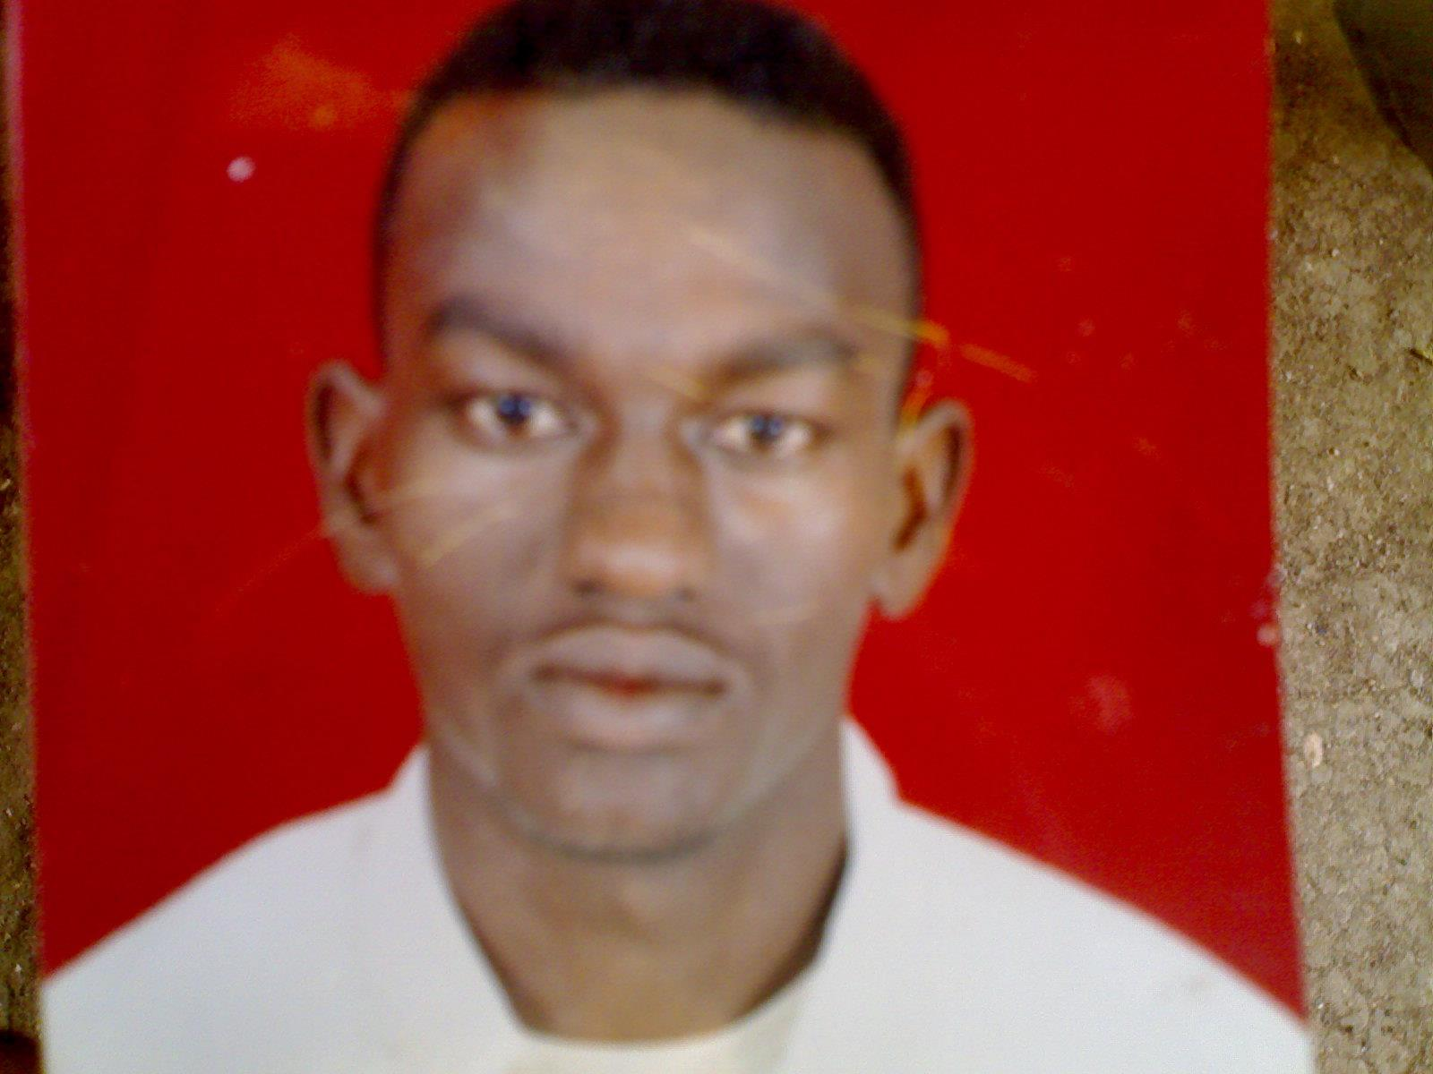

A

(1) Things Fall Apart :

- The book of Things Fall Apart written by……
=Chinua Achebe
- Okonkwo lived in small village called…………
=Iguedo.
- Okonkwo lived in district called………………
=Umuofia.
- Okonkwo’s father was called……=Anoka.
- Okonkwo’s second wife was called…………………
=Ekwife.
- Okonkwo’s third wife was called ……………………
=Ojiugo.
- Okonkwo’s eldest son was called……………………
=Nwoye.
- Okonkwo’s daughter was called ……………………
=Ezinma.
- Okonkwo’s uncle in Mbanta was called……
=Unchendo.
- Okonkwo’s best and closest friend was called..
=Obierika.

- Obierika’s son was called………………
=Maduka.
- The oldest man in Umuofia was called……
=Ezeudo
- The boy that brought form other clan was called……………
=Ikrmefuna.
- The first English Missionary in Umuofia was called……………
=Mr. Brown.
- The second English Missionary in Umuofia was called……
=Mr. Smith.
- The head of the church in Mbata was called…………
=Mr. Kiaga.
- The priestess of the God, Agbala was called..
=Chielo.
- The villages in Umuofia were…………
= nine Villages.
- The story of “Things Fall Apart” is story about……..
= about life in Africa before Europeans came.
- How a man can be leader in Umuofia?
= by work and ability.

- How did Okonkwo become a famous?
= he became a famous by wrestling and fighting.
= he became a famous he fought the best wrestler and won the match at eighteen years old.
- Describe Okonkwo’s father ;Unoka;
- He is very lazy person.
- Does not like work.
- Does not like seeing blood.
- Afraids of fighting.
- Likes music so much.
- Briefly describe Okonkwo…………………….
………………………………………………………………………………………………………………………………………………………………………………………………………………………………………………………………………………………………………………………………………………………………………………………………………………………………………………………………………………………………………………......................
- In the week of peace………..
- People were not allowed to fight.
- People have to be kind each other.
- Husbands were not allowed to beat their wives and children.
- Okonkwo fought the best wrestler and won the match at…..
= eighteen years old.
- Why anyone in the clan respects Okonkwo?
=Because he is not like his father.
- Why were the other districts afraid of Umuofia?
=Because it’s a powerful and strong.
- How long did Ikmefuna live with Okonkow’s family?
=He lived for three years.
- What kind of stories did Okonkow tell to Nwoye?
=bout war and fighting.
- Where did Okonkwo’ mother live?
= she lived in Mbanta.

- How did okonkow break the Week of Peace?
=By beating his third wife Ojiugo.
- What is the name of the boy who won the match?
= he was called Maduka.
- What is the name of the man who won the match?
= he was called Okafa.
- Why did Okonkow beat his third wife Ojiugo?
= because she was not at home and did not cook the meal.
- What kind of stories did Nwoye’s mother tell to Nwoye?
=bout animals and birds.
- Why did Okonkwo killed Ikemefuna?
=Because he afraid that his friends would think that he is weak.
- Why did mothers throw their twins into the forest?
=Because they think that twins bring the bad luck.
- Why did Okonkwo keep beating Nwoye?
=Because he was afraid that his son will grow up like his grandfather ;Unoka.
- Why were the first two days of the New Year so important?
=first day was for large meals
and the second day was for the big wrestling matches.
- What did Okonkwo use to make Ezinma well?
= he used grasses, leaves and roots of trees.

- Where was Ezinma going?
=Ezinma was going to see Agbala
- Who took Ezinma to Agbala? Chielo.
- There were two kinds of crimes what were they?
=A male crime.
=A female crime.
- What was the male crime?
= Male crime was when the crime was not an accident. {Intentionally}
- What was the female crime?
- Female crime was when the crime was an accident. {Unintentionally}
- What kind of crime did Okonkwo commit?
=Female crime.
- What did Ezeudu’s friends do to Okonkwo’s compound?
1= They set fire to Okonkwo’s huts.
2= They knocked down the red wall.
3=They killed all his animals.
4= They knocked down his barn.
- What did happen to Okonkwo’s compound?
= it has been destroyed by Ezeudu’s friends.
- Why did Mr. Brown build a school?
= to teach them Christianity.

- Where did Mr. Brown build a school?
= in little hospital.
- Why did the clansmen burn the church?
= because they did not like the new religion.
- What did happen to the clan in Umuofia?
= the white men had broke up the clan.
- How Umuofia was getting rich?
=by selling crops to other countries.
- What is Nwoye’s new name?.......... Isaac
- Why did Mr Brown leave Umuofia?
=Because he was ill.
- How Okonkwo knew that the people of Umuofia would not fight the white man?
=Because they let the other messengers run away.
- How was the Okonkwo’s death?
=He hanged himself on a tree.
- How did Okonkwo kill himself?
=By hanging on a tree.
- Where did the clansmen find Okonkwo’s body?
=Hanging on a tree.

- Why the clansmen refused to burry Okonkwo’s body?
=Because it is against their law.
=because it is a crime.
- According to your opinion why did Okonkwo hang himself?
Because Okonkwo knew that the white man would hang him if he found him alive.
…………………………………………………………………………………………………………………………………………………………………………………………………………………………………………………………………………………………………………

- Draw a circle around the letter of the most correct alternative a, b, c or d:
- Okonkwo fought the best wrestler and won the match at ……. Years old.
- Six. c- sixteen.
- eighteen. d- nine.
- Okonkwo’s father was…..
- very lazy person.
- afraid of fighting.
- Afraid of war.
- d- all mentioned.

- The villages in district of Umuofia were.
- Five villages b- two villages.
- eight villages d- nine villages.

- In the Week of Peace…..
- People were not allowed to fight.
- People have to be kind each other.
- No wives and children to be beaten.
- All above.
- The boy who brought from other clan was called.
- Obierika b- Unoka
c- Ikemefuna d-Nwoye.

- The first English Missionary in Umuofia.
- Mr. Smith. c- Mr. kiaga.
- -Mr. Brown. d-no one.
- What did Ezeudu’s friends do to Okonkwo’s compound?
- They set fire to Okonkwo’s huts.
- They knocked down the red wall.
- They killed all his animals.
- They knocked down his barn.
- all mentoned.

- Who said this ………... I wish Ezinma were a boy….?
- Nwoye. c- Unoka.
- Okonkwo. d- Obierika.

- Who said this …………. Father they have killed me.
- Maduka. c- Ikemefuna.
- Okonkwo. d- Nwoye.
- Who said this ………... Ezinma is dying said in very sad voice….?
- Nwoye. c- Ojiugo.
- Okonkwo. d- Ekwefi.

- Who said this ………... the white man is very clever.
- Okonkow. c- Obierika.
- Mr Brown. d-Unoka.
- Ezinma was going to see……………………………
- Mbanta. b- Agbala.
- Okonkwo. d- Ekwefi.

- The boy who won the match was called?
- Nwoye. b- Maduka.
- Ekemefuna. d- Obierika.

- The man who won the greatest wrestling match was called?
- Maduka. c- Ikezue.
- Okafa. d- Obierika.

- The man who lost the great wrestling match was called?
- Maduka. c- Ikezue.
- Okafa. d- Obierika.

- Umuofia was getting rich by selling……………..
- Goats. c- cows.
- crops. d- all metined
- The commissioner was the ………………. Of Umuofia.
- Leader. b- Ruler.
- doctor. d- teacher.
- The messengers who went to the market place to stop the meeting were…………….
- Six. b- five. c- four. d- three.
- The messengers who run from the market place were…………….
- Six. b- five. c- four. d- three.
- How old was Ikemefuna when he was brought to Umuofia?
……………………………………………………………………..
- How old was Ikemefuna when he was killed by Okonkow?
………………………………………………………………………………………..
- How long did Ikemefuna stay in Okonkow’s house?
……………………………………………………………………………..
- Nwoye is younger than Ikemefuna by…………………….... old.
- Ikemefuna is older than Nwoye by………………………….. old.
- Okonkow’ children when he arrived Mbanta were………..
- In the greatest match or in the men’s match there were ……………… in each team.
- In the boys match there were ……………….. in each team.

- Match ‘A’ with ‘B’ in column (C)from (B).
A | C | B
- Mr Kiaga |  | a—Okonkow’ second wife.
- Unoka |  | b—The second English Missionary in Umufia.
- Mr Smith |  | c—head of the Church in Mbanta.
- Nwoye |  | d—He is lazy, does not like work, afraid of seeing blood and like music so much.
- Ekwefi |  | e—Okonkow’s eldest son.
- Uchendu |  | f-Okonkow’ third wife.
- Ekemefuna |  | g— Okonkow’s uncle.
- Ekwife |  | h—the clan at Abame is now destroyed.
- Ojiugo |  | i—. Ezinma is dying
- Obierika |  | j— The first English Missionary in Umufia.
- Mr Brown |  | k— My father, they have killed me.
- Ezeudu |  | m-the land of the brave.
- Umuofia obodo dike |  | n- the oldest man in Umuofia.
- Obierika |  | L-The Holy Snake.
15-Our Father. |  | o-Perhaps your men can help us.

- Match ‘A’ with ‘B’ in column (C)from (B).
B | C | A
a- Bad Luck. |  | 1- Okonkow
b-the most important god. |  | 2-Okika
c-“Nigeria” life in Africa before European Came. |  | 3-Twins
d- the one who is a good speaker. |  | 4-The Earth godless
e- the main character in the story. |  | 5-“Thing Fall Apart” Setting

